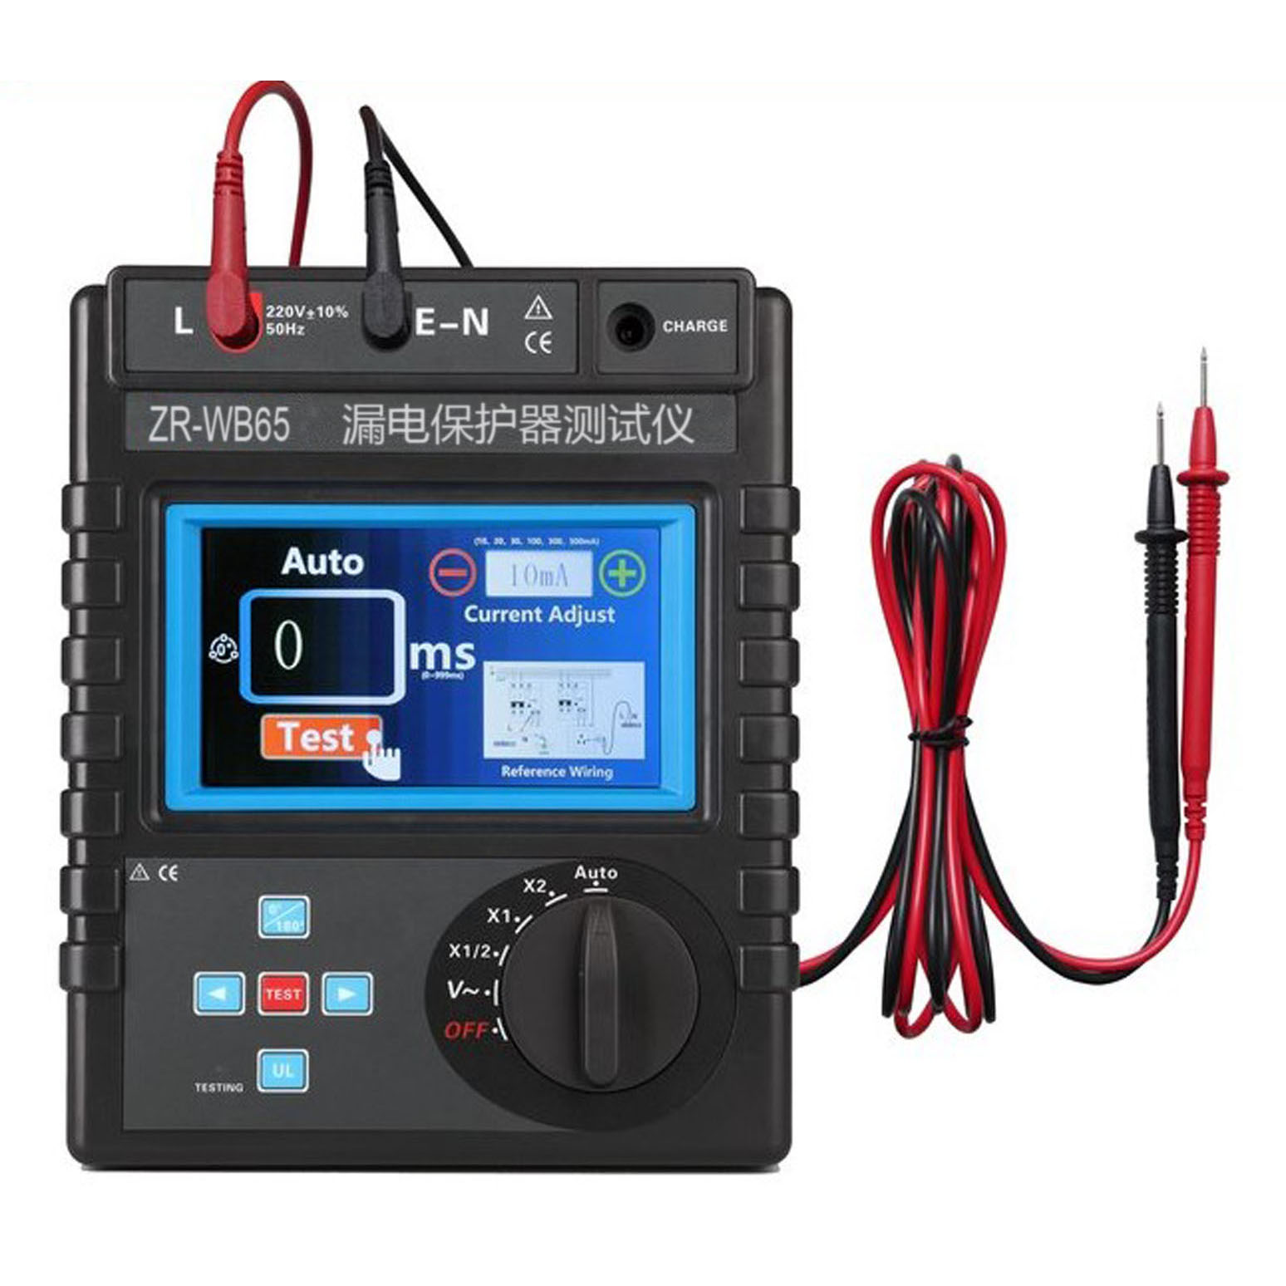
<a href="/products/etcr/jd/" se_prerender_url="loading" target="_blank"><span style="color:#cccccc;">01.接地电阻测试仪</span></a><span style="color:#cccccc;">,&nbsp;&nbsp;</span><a href="/products/etcr/jy/" target="_blank"><span style="color:#cccccc;">02.绝缘电阻测试仪</span></a><span style="color:#cccccc;">,&nbsp;&nbsp;</span><a href="/products/etcr/zl/" target="_blank"><span style="color:#cccccc;">03.直流电阻测试仪</span></a><span style="color:#cccccc;">,&nbsp;&nbsp;</span><a href="/products/etcr/qx/" se_prerender_url="complete" target="_blank"><span style="color:#cccccc;">04.钳形电流表</span></a><span style="color:#cccccc;">,&nbsp;&nbsp;</span><a href="/products/etcr//cly/" target="_blank"><span style="color:#cccccc;">05.高低压钳形电流表</span></a><span style="color:#cccccc;">,&nbsp;&nbsp;</span><a href="/products/etcr/ydq/" target="_blank"><span style="color:#cccccc;">06.高压验电器/验电器</span></a><span style="color:#cccccc;">,&nbsp;&nbsp;&nbsp;</span><a href="/products/etcr/tq/" target="_blank"><span style="color:#cccccc;">07.台区识别</span></a><span style="color:#cccccc;">,&nbsp;&nbsp;</span><a href="/products/etcr/ldbh/" target="_blank"><span style="color:#cccccc;">08.漏电保护器测试仪</span></a><span style="color:#cccccc;">,&nbsp;&nbsp;&nbsp;&nbsp;</span><a href="/products/etcr/yhx/" target="_blank"><span style="color:#cccccc;">09.氧化锌避雷器测试仪</span></a><span style="color:#cccccc;">,&nbsp;&nbsp;</span><a href="/products/etcr/jkjd/" target="_blank"><span style="color:#cccccc;">10.架空线路接地故障巡查</span></a><span style="color:#cccccc;">,&nbsp;&nbsp;</span><a href="/products/etcr/flyj/" target="_blank"><span style="color:#cccccc;">11.防雷元件测试仪</span></a><span style="color:#cccccc;">,&nbsp;&nbsp;</span><a href="/products/etcr/xwfan/" target="_blank"><span style="color:#cccccc;">12.相位伏安表</span></a><span style="color:#cccccc;">,&nbsp;&nbsp;</span><a href="/products/etcr/PT2c/" target="_blank"><span style="color:#cccccc;">13.PT二次压降测试仪</span></a><span style="color:#cccccc;">,&nbsp;&nbsp;</span><a href="/products/etcr/CTbbi/" se_prerender_url="complete" target="_blank"><span style="color:#cccccc;">14.高低压CT变比测试仪</span></a><span style="color:#cccccc;">,&nbsp;&nbsp;</span><a href="/products/etcr/txcx/" target="_blank"><span style="color:#cccccc;">15.变压器铁芯接地电流</span></a><span style="color:#cccccc;">,&nbsp;&nbsp;</span><a href="/products/etcr/wyb/" target="_blank"><span style="color:#cccccc;">16.电压表/万用表</span></a><span style="color:#cccccc;">,&nbsp;&nbsp;</span><a href="/products/etcr/AVzx/" target="_blank"><span style="color:#cccccc;">17.电流/电压在线监测记录</span></a><span style="color:#cccccc;">,&nbsp;&nbsp;</span><a href="/products/etcr/hxy/" target="_blank"><span style="color:#cccccc;">18.高低压核相仪/相序表</span></a><span style="color:#cccccc;">,&nbsp;&nbsp;</span><a href="/products/etcr/dlhgq/" target="_blank"><span style="color:#cccccc;">19.钳形电流互感器</span></a><span style="color:#cccccc;">,&nbsp;&nbsp;</span><a href="/products/etcr/xlhgq/" target="_blank"><span style="color:#cccccc;">20.泄露电流互感器</span></a><br />
<span style="font-size:16px;"><span style="background-color:#008000;"><span style="color:#ffffff;">ZR-WB65漏电保护器测试仪</span></span></span><br />
<br />
<a href="http://cloud.video.taobao.com/play/u/null/p/1/e/6/t/1/406050558142.mp4" target="_blank"><img alt="" src="http://www.ye-bao.com/uploads/20sbqi/ZR/zrs.jpg" style="width: 251px; height: 255px;" /></a><br />
<a href="/uploads/20sbqi/EC8600B1.JPG" target="_blank"><img alt="ZR-WB65漏电保护器测试仪" src="http://www.ye-bao.com/uploads/20sbqi/ZR/EC8600B1.jpg" style="width: 800px; height: 800px;" /></a><br />
<a href="/uploads/20sbqi/ZR/EC8600B5.jpg" target="_blank"><img alt="ZR-WB65漏电保护器测试仪" src="http://www.ye-bao.com/uploads/20sbqi/ZR/EC8600B5.jpg" style="width: 800px; height: 563px;" /></a><br />
<br />
<a href="/uploads/20sbqi/ZR/EC8600B6.jpg" target="_blank"><img alt="ZR-WB65漏电保护器测试仪" src="http://www.ye-bao.com/uploads/20sbqi/ZR/EC8600B6.jpg" style="width: 800px; height: 600px;" /></a><br />
<a href="ZR-WB65漏电保护器测试仪" target="_blank"><img alt="ZR-WB65漏电保护器测试仪" src="http://www.ye-bao.com/uploads/20sbqi/ZR/EC8600B2.jpg" style="width: 800px; height: 800px;" /></a><img alt="ETCR8600B漏电保护器测试仪" src="http://www.ye-bao.com/uploads/20sbqi/ZR/EC8600B3.jpg" style="width: 800px; height: 800px;" /><img alt="ETCR8600B漏电保护器测试仪" src="http://www.ye-bao.com/uploads/20sbqi/ZR/EC8600B4.jpg" style="width: 800px; height: 800px;" /><br />
<br />
ZR-WB65漏电保护器测试仪专为现场在线测试各种漏电保护器的线路交流电压、以及漏电动作时间，采用854&times;480全彩触摸LCD显示，具有电池电量显示、设定故障电压指示、背光亮度调节、内设接线指导图，方便直观，操作简便。测试电流从5～1000mA分十六档，测试漏电流动作时间量程为0～999ms，仪表精度高、体积小、重量轻、外观精致，便于携带，是各种漏电保护器现场或<br />
<br />
漏电动作时间量程：0ms~999ms<br />
线路交流电压量程：0~600V<br />
漏电动作电流量程：5mA～1000mA<br />
额定电压：AC 220V（漏电保护开关测试时，仪表接口之间）<br />
漏电保护开关测试线路：220V/380V<br />
LCD：5英寸TFT彩色触摸屏<br />
内部设接线指导图<br />
<br />
专为现场在线测试各种漏电保护器的漏电动作时间、以及线路交流电压。测试电流从5～1000mA分十六档(5、10、15、20、30、40、50、60、100、150、200、250、300、500、600、1000mA)，测试漏电流动作时间量程为0～999ms，采用5寸全彩触摸屏LCD显示，具有电池电量显示、自动关机、设定故障电压指示、背光亮度调节、当前日期时间显示、数据存储功能，内设接线指导图，指示清晰，操作简便。仪表精度高、体积小、重量轻、外观精致，便于携带，是各种漏电保护器现场或室内检测的理想工具。<br />
&nbsp;<br />
&nbsp;<br />
产品特点<br />
1.漏电保护测试仪，采用触摸彩屏，具有测试电流及倍率选择、相位角度选择、设定故障电压指示、背光亮度调节、内设接线指导图、电池电量显示等功能。<br />
2.可选5～1000mA十六档测试电流，满足各种使用需求。<br />
3.具有交流电压测试档位，可测试保护器实时线路交流电压。<br />
4.采用可充电大容量锂电池。<br />
<p style="line-height: 1.5;">
<span style="color: rgb(0, 0, 0); font-family: 微软雅黑; font-size: 12pt;">一、量程及精度</span></p>
<table border="1" cellpadding="2" cellspacing="0" style="width: 800px;">
<tbody>
<tr>
<td style="text-align: center;">
<span style="color: rgb(0, 0, 0); font-family: 微软雅黑; font-size: 12pt;">测量功能</span></td>
<td style="text-align: center;">
<span style="color: rgb(0, 0, 0); font-family: 微软雅黑; font-size: 12pt;">量程</span></td>
<td style="text-align: center;">
<span style="color: rgb(0, 0, 0); font-family: 微软雅黑; font-size: 12pt;">精度</span></td>
</tr>
<tr>
<td>
<p style="text-align: center;">
<span style="color: rgb(0, 0, 0); font-family: 微软雅黑; font-size: 12pt;">漏电动作时间</span></p>
</td>
<td>
<p style="text-align: center;">
<span style="color: rgb(0, 0, 0); font-family: 微软雅黑; font-size: 12pt;">0～999ms</span></p>
</td>
<td>
<p style="text-align: center;">
<span style="color: rgb(0, 0, 0); font-family: 微软雅黑; font-size: 12pt;">&plusmn;5%rdg&plusmn;3dgt</span></p>
</td>
</tr>
<tr>
<td style="text-align: center;">
<span style="color: rgb(0, 0, 0); font-family: 微软雅黑; font-size: 12pt;">漏电流</span></td>
<td style="text-align: center;">
<span style="color: rgb(0, 0, 0); font-family: 微软雅黑; font-size: 12pt;">0～1000mA</span></td>
<td style="text-align: center;">
<span style="color: rgb(0, 0, 0); font-family: 微软雅黑; font-size: 12pt;">&plusmn;10%rdg&plusmn;5dgt</span></td>
</tr>
<tr>
<td style="text-align: center;">
<span style="color: rgb(0, 0, 0); font-family: 微软雅黑; font-size: 12pt;">交流电压</span></td>
<td style="text-align: center;">
<span style="color: rgb(0, 0, 0); font-family: 微软雅黑; font-size: 12pt;">0～600V</span></td>
<td style="text-align: center;">
<span style="color: rgb(0, 0, 0); font-family: 微软雅黑; font-size: 12pt;">&plusmn;2rgt%rdg&plusmn;3dgt</span></td>
</tr>
</tbody>
</table>
<p style="line-height: 1.5;">
&nbsp;</p>
<p style="line-height: 1.5;">
<span style="color: rgb(0, 0, 0); font-family: 微软雅黑; font-size: 12pt;">二、其他参数</span></p>
<table border="1" cellpadding="0" cellspacing="0" style="width: 800px;">
<tbody>
<tr>
<td class="xl63" height="35" style="width: 126.82px; height: 35px; text-align: center;" width="205">
<span style="color: rgb(0, 0, 0); font-family: 微软雅黑; font-size: 12pt;">电&nbsp;&nbsp;&nbsp; 源</span></td>
<td class="xl64" style="width: 670.17px;" width="651">
<span style="color: rgb(0, 0, 0); font-family: 微软雅黑; font-size: 12pt;">&nbsp; 7.4V 可充电锂电池(充满约8.4V)&nbsp;</span></td>
</tr>
<tr>
<td style="width: 126.82px; text-align: center;" width="144">
<p>
<span style="color: rgb(0, 0, 0); font-family: 微软雅黑; font-size: 12pt;">额定电压</span></p>
</td>
<td style="width: 670.17px;" width="535">
<p>
<span style="color: rgb(0, 0, 0); font-family: 微软雅黑; font-size: 12pt;">AC 220V（漏电保护开关测试时，仪表接口之间）</span></p>
</td>
</tr>
<tr>
<td style="width: 126.82px; text-align: center;" width="144">
<p>
<span style="color: rgb(0, 0, 0); font-family: 微软雅黑; font-size: 12pt;">漏电保护开关测试线路</span></p>
</td>
<td style="width: 670.17px;" width="535">
<p>
<span style="color: rgb(0, 0, 0); font-family: 微软雅黑; font-size: 12pt;">220V/380V</span></p>
</td>
</tr>
<tr>
<td class="xl63" height="35" style="width: 126.82px; height: 26.25pt; text-align: center;" width="205">
<span style="color: rgb(0, 0, 0); font-family: 微软雅黑; font-size: 12pt;">漏电电流档位</span></td>
<td class="xl64" style="width: 670.17px;" width="651">
<span style="color: rgb(0, 0, 0); font-family: 微软雅黑; font-size: 12pt;">&nbsp; (5、10、15、20、30、40、50、60、100、150、200、250、300、500、600、1000)mA</span></td>
</tr>
<tr>
<td class="xl63" height="35" style="width: 126.82px; height: 26.25pt; text-align: center;" width="205">
<span style="color: rgb(0, 0, 0); font-family: 微软雅黑; font-size: 12pt;">交流电压档位</span></td>
<td class="xl64" style="width: 670.17px;" width="651">
<span style="color: rgb(0, 0, 0); font-family: 微软雅黑; font-size: 12pt;">&nbsp; 0～600V</span></td>
</tr>
<tr>
<td class="xl63" height="35" style="width: 126.82px; height: 26.25pt; text-align: center;" width="205">
<span style="color: rgb(0, 0, 0); font-family: 微软雅黑; font-size: 12pt;">失效信息指示</span></td>
<td class="xl64" style="width: 670.17px;" width="651">
<span style="color: rgb(0, 0, 0); font-family: 微软雅黑; font-size: 12pt;">&nbsp; LCD显示&ldquo;999&rdquo;超时指示，可能测试的额定动作电流档位太小或漏电保护器有故障</span></td>
</tr>
<tr>
<td class="xl63" height="35" style="width: 126.82px; height: 26.25pt; text-align: center;" width="205">
<span style="color: rgb(0, 0, 0); font-family: 微软雅黑; font-size: 12pt;">测试线长</span></td>
<td class="xl65" style="width: 670.17px;" width="651">
<span style="color: rgb(0, 0, 0); font-family: 微软雅黑; font-size: 12pt;">&nbsp; 1.8m</span></td>
</tr>
<tr>
<td class="xl63" height="35" style="width: 126.82px; height: 26.25pt; text-align: center;" width="205">
<span style="color: rgb(0, 0, 0); font-family: 微软雅黑; font-size: 12pt;">测试模式</span></td>
<td class="xl64" style="width: 670.17px;" width="651">
<span style="color: rgb(0, 0, 0); font-family: 微软雅黑; font-size: 12pt;">&nbsp; 手动或自动</span></td>
</tr>
<tr>
<td class="xl63" height="35" style="width: 126.82px; height: 26.25pt; text-align: center;" width="205">
<span style="color: rgb(0, 0, 0); font-family: 微软雅黑; font-size: 12pt;">显示模式</span></td>
<td class="xl64" style="width: 670.17px;" width="651">
<span style="color: rgb(0, 0, 0); font-family: 微软雅黑; font-size: 12pt;">&nbsp; LCD：5英寸TFT彩色触摸屏</span></td>
</tr>
<tr>
<td class="xl63" height="35" style="width: 126.82px; height: 26.25pt; text-align: center;" width="205">
<span style="color: rgb(0, 0, 0); font-family: 微软雅黑; font-size: 12pt;">仪表尺寸</span></td>
<td class="xl64" style="width: 670.17px;" width="651">
<span style="color: rgb(0, 0, 0); font-family: 微软雅黑; font-size: 12pt;">&nbsp; 215mm&times;178mm&times;83mm</span></td>
</tr>
<tr>
<td style="width: 126.82px; text-align: center;">
<span style="color: rgb(0, 0, 0); line-height: 2; font-family: 微软雅黑; font-size: 12pt;">仪表质量</span></td>
<td style="width: 670.17px;">
<span style="color: rgb(0, 0, 0); font-family: 微软雅黑; font-size: 12pt;"><span style="line-height: 2;">&nbsp; </span><span style="line-height: 2;">主机：约944g（含电池）；总重量：约2kg（含包装）</span></span></td>
</tr>
<tr>
<td class="xl63" height="35" style="width: 126.82px; height: 26.25pt; text-align: center;" width="205">
<span style="color: rgb(0, 0, 0); font-family: 微软雅黑; font-size: 12pt;">电池电压</span></td>
<td class="xl64" style="width: 670.17px;" width="651">
<span style="color: rgb(0, 0, 0); font-family: 微软雅黑; font-size: 12pt;">&nbsp; 当电池电压降到7.0V时，提示电池电压低，请及时充电。此时测量的数据同样是准确的</span></td>
</tr>
<tr>
<td class="xl66" height="35" style="width: 126.82px; height: 26.25pt; text-align: center;" width="205">
<span style="color: rgb(0, 0, 0); font-family: 微软雅黑; font-size: 12pt;">工作电流</span></td>
<td class="xl64" style="width: 670.17px;" width="651">
<span style="color: rgb(0, 0, 0); font-family: 微软雅黑; font-size: 12pt;">&nbsp; 365mA Max</span></td>
</tr>
<tr>
<td class="xl63" height="35" style="width: 126.82px; height: 26.25pt; text-align: center;" width="205">
<span style="color: rgb(0, 0, 0); font-family: 微软雅黑; font-size: 12pt;">工作温湿度</span></td>
<td class="xl64" style="width: 670.17px;" width="651">
<span style="color: rgb(0, 0, 0); font-family: 微软雅黑; font-size: 12pt;">&nbsp; -10℃～40℃；80%RH以下</span></td>
</tr>
<tr>
<td class="xl63" height="35" style="width: 126.82px; height: 26.25pt; text-align: center;" width="205">
<span style="color: rgb(0, 0, 0); font-family: 微软雅黑; font-size: 12pt;">存放温湿度</span></td>
<td class="xl64" style="width: 670.17px;" width="651">
<span style="color: rgb(0, 0, 0); font-family: 微软雅黑; font-size: 12pt;">&nbsp; -10℃～60℃；70%RH以下</span></td>
</tr>
<tr>
<td class="xl66" height="35" style="width: 126.82px; height: 26.25pt; text-align: center;" width="205">
<span style="color: rgb(0, 0, 0); font-family: 微软雅黑; font-size: 12pt;">绝缘耐压</span></td>
<td class="xl67" style="width: 670.17px;" width="651">
<span style="color: rgb(0, 0, 0); font-family: 微软雅黑; font-size: 12pt;">&nbsp; 100M&Omega;或更大, AC2kV/rms(外壳与螺丝之间)</span></td>
</tr>
<tr>
<td class="xl66" height="35" style="width: 126.82px; height: 26.25pt; text-align: center;" width="205">
<span style="color: rgb(0, 0, 0); font-family: 微软雅黑; font-size: 12pt;">适合安规</span></td>
<td class="xl64" style="width: 670.17px;" width="651">
<span style="color: rgb(0, 0, 0); font-family: 微软雅黑; font-size: 12pt;">&nbsp; IEC1010-1、IEC1010-2-032、污染等级2、CAT Ⅲ(600V) IEC61326(EMC标准)</span></td>
</tr>
</tbody>
</table>
<br />
<table border="1" style="width: 850px; border-collapse: collapse;">
<tbody>
<tr>
<td style="text-align: center;" width="68">
<p>
<strong>型号</strong></p>
</td>
<td style="text-align: center;" width="71">
<p>
<strong>漏电电流</strong></p>
<p>
<strong>档位</strong></p>
</td>
<td style="text-align: center;" width="64">
<p>
<strong>漏电动作</strong></p>
<p>
<strong>时间量程</strong></p>
</td>
<td style="text-align: center;" width="66">
<p>
<strong>交流电压</strong></p>
<p>
<strong>量程</strong></p>
</td>
<td style="text-align: center;" width="44">
<p>
<strong>充电功能</strong></p>
</td>
<td style="text-align: center;" width="111">
<p>
<strong>特点</strong></p>
</td>
</tr>
<tr>
<td style="text-align: center;" width="68">
<p>
ZR-WB60</p>
</td>
<td style="text-align: center;" width="71">
<p>
15～500mA</p>
</td>
<td style="text-align: center;" width="64">
<p>
0～999ms</p>
</td>
<td style="text-align: center;" width="66">
<p>
无</p>
</td>
<td style="text-align: center;" width="44">
<p>
无</p>
</td>
<td style="text-align: center;" width="111">
<p>
便携式</p>
<p>
测量漏电动作时间</p>
</td>
</tr>
<tr>
<td style="text-align: center;" width="68">
<p>
ZR-WB65</p>
</td>
<td style="text-align: center;" width="71">
<p>
3～500mA</p>
</td>
<td style="text-align: center;" width="64">
<p>
0～999ms</p>
</td>
<td style="text-align: center;" width="66">
<p>
0～280V</p>
</td>
<td style="text-align: center;" width="44">
<p>
无</p>
</td>
<td style="text-align: center;" width="111">
<p>
超大LED屏幕</p>
<p>
测量漏电动作时间</p>
</td>
</tr>
<tr>
<td style="text-align: center;" width="68">
<p>
ZR-WB70</p>
</td>
<td style="text-align: center;" width="71">
<p>
5～1000mA</p>
</td>
<td style="text-align: center;" width="64">
<p>
0～999ms</p>
</td>
<td style="text-align: center;" width="66">
<p>
0～600V</p>
</td>
<td style="text-align: center;" width="44">
<p>
有</p>
</td>
<td style="text-align: center;" width="111">
<p>
彩色触摸屏</p>
<p>
测量漏电动作时间</p>
</td>
</tr>
</tbody>
</table>
<br />
<table border="1" cellpadding="0" cellspacing="0" style="width: 600px;">
<tbody>
<tr>
<td class="xl65" height="35" style="width: 50%;" width="254">
<span style="font-family: Microsoft YaHei; font-size: 16px;">主机</span></td>
<td class="xl65" style="width: 447pt;" width="596">
<span style="font-family: Microsoft YaHei; font-size: 16px;">1台</span></td>
</tr>
<tr>
<td class="xl65" height="35" style="width: 191pt; height: 26.25pt;" width="254">
<span style="font-family: Microsoft YaHei; font-size: 16px;">仪表包</span></td>
<td class="xl65" style="width: 447pt;" width="596">
<span style="font-family: Microsoft YaHei; font-size: 16px;">1个</span></td>
</tr>
<tr>
<td class="xl65" height="35" style="width: 191pt; height: 26.25pt;" width="254">
<span style="font-family: Microsoft YaHei; font-size: 16px;">充电器</span></td>
<td class="xl65" style="width: 447pt;" width="596">
<span style="font-family: Microsoft YaHei; font-size: 16px;">1个</span></td>
</tr>
<tr>
<td class="xl65" height="35" style="width: 191pt; height: 26.25pt;" width="254">
<span style="font-family: Microsoft YaHei; font-size: 16px;">表笔测试线</span></td>
<td class="xl65" style="width: 447pt;" width="596">
<span style="font-family: Microsoft YaHei; font-size: 16px;">2条</span></td>
</tr>
<tr>
<td class="xl65" height="35" style="width: 191pt; height: 26.25pt;" width="254">
<span style="font-family: Microsoft YaHei; font-size: 16px;">鳄鱼夹</span></td>
<td class="xl65" style="width: 447pt;" width="596">
<span style="font-family: Microsoft YaHei; font-size: 16px;">1个</span></td>
</tr>
<tr>
<td class="xl65" height="35" style="width: 191pt; height: 26.25pt;" width="254">
<span style="font-family: Microsoft YaHei; font-size: 16px;">插座测试线</span></td>
<td class="xl65" style="width: 447pt;" width="596">
<span style="font-family: Microsoft YaHei; font-size: 16px;">1条</span></td>
</tr>
<tr>
<td class="xl65" height="35" style="width: 191pt; height: 26.25pt;" width="254">
<span style="font-family: Microsoft YaHei; font-size: 16px;">包装盒</span></td>
<td class="xl65" style="width: 447pt;" width="596">
<span style="font-family: Microsoft YaHei; font-size: 16px;">1个</span></td>
</tr>
<tr>
<td class="xl65" height="35" style="width: 191pt; height: 26.25pt;" width="254">
<span style="font-family: Microsoft YaHei; font-size: 16px;">用户手册、保修卡、合格证</span></td>
<td class="xl65" style="width: 447pt;" width="596">
<span style="font-family: Microsoft YaHei; font-size: 16px;">1份</span></td>
</tr>
</tbody>
</table>
<p>
&nbsp;</p>

